Activity 1. Practicing Terminology – Jeopardy
- Aligned to Learning Outcome: Define the terms: pull, push, force, speed, velocity, frictional force, mass, balanced force, unbalanced force, gravity force and magnetic force.

Instructions:
- Students will engage in a game of jeopardy to assess students' knowledge on defining the terms.
- Students can work individually or in groups. Write a list of the words in an area where all can view. (pull, push, force, friction, mass, balanced force, unbalanced force, gravity).
- On an empty wall, create a grid with 16 papers (letter size) (4x4). Each grid will have points ranging from 100 to 400. Under each grid will be 8 definitions and 8 scenarios.
- Under the paper the teacher will write the definitions as written below.
Term | Definition
Push | The act of moving an object away from oneself.
Pull | The act of moving an object towards oneself.
Force | Any push or pull on an object.
Friction | A force that acts between two objects that are in contact with one another.
Mass | The measurement of how much matter is contained in an object.
Balanced Force | The acting on an object which does not change the state of rest or uniform motion of it.
Unbalanced Force | When the force applied in one direction is greater than the force applied in the opposite direction.
Gravity | The force that attracts a body towards the centre of the earth, or towards any other physical body having mass.

- Use these Jeopardy Answers and Questions:
Statement | Definition
I am turning up the volume on my cell phone. Which word describes the force that I used? | What is push?
I am trying to take my book from my teacher. What word best describes the force that is used? | What is pull?
I placed my pencil on the table but it rolled off. | What is an unbalanced force?
I throw my ball up towards the ceiling but it always seems to fall back down. What word best describes the force that pulls the ball down? | What is gravity?
I placed my apple on my stack of textbooks and it's not moving. What word best describes this force? | What is a balanced force?
I am pushing my dresser across my bedroom. What am I creating between the floor and the dresser? | What is friction?
I can choose to push or pull my grocery cart. What do I use to move the cart? | What is force?
I can be heavy or light. | What is mass?

- The teacher will decide on the arrangement on the grid with the top row being 100 points, 2nd row being 200 points, third row being 300 points, and bottom row being 400 points. Here is sample grid:
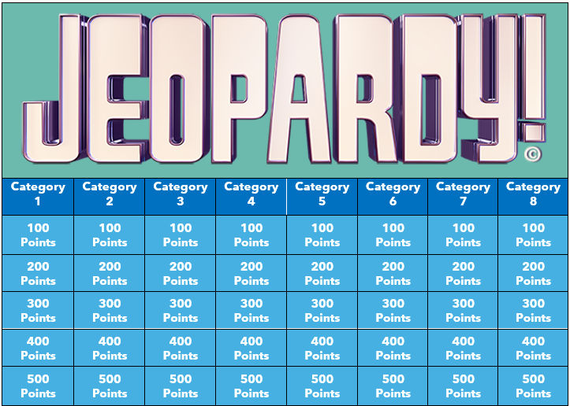
Figure 1Jeopardy Grid (Source: Author)
- When the student is ready to play they will select the points they want added to their total score. If they get the answer or respond correctly the points will be added to their total. If they did not respond correctly the teacher will give the next student or team a chance to respond and if they get it correctly, they get the score. Now if no one gets it, then the teacher will reveal the answer and the sheet is placed on the side.

